Better Stands Programme – Service Provider and EAC Invitation and Information Sharing x

Dear [name]

Our events wouldn’t be successful without 1000s of service providers around the world doing a fantastic job in helping exhibitors, as our mutual customers, have a successful show.

We all know that a great show really comes from successful partnerships, but even better long-term success comes from having one eye to the future. Over the last decade, we’ve seen attendees and participants become more interested in, and have higher expectations, of our events. This ranges from the quality of the content, the safety of people, the diversity of attendees and the sustainability of our builds.

With that in mind, we are part of the global Better Stands programme. The goal of this is to celebrate those exhibitors and their service providers who choose to use reusable [booths/stands] as we believe they provide a better experience for everyone.

We are writing to you to explain more, and hope that you’ll join us on this programme. [In (insert year) we introduced/next edition we plan to introduce], where we will be encouraging exhibitors to use reusable [booths/stands]. By doing this and moving away from the use of single use [booths/stands], we believe that we will improve the exhibitor experience as well as meet growing stakeholder demands for a more sustainable event.

We have had feedback from many service providers who already supply reusable [booths/stands] that they can provide a number of benefits:
- A smoother, more predictable and stress-fee build and dismantle experience for all parties
- Reusable [booths/stands] remove the likelihood of requiring early access or late working with subsequent additional costs
- Increased client retention rates as exhibitors are more likely to use you multiple times if you meet the desired standard
- More frequent success in tenders due to the boost from sustainability credentials
- Reduced waste bills and less likelihood of other unpredicted costs
- Easier process of monitoring and improving safety – Reusable [booths/stands] reduce the likelihood of accidents and incidents occurring during the build and dismantle of your [booth/stand]
- Reduced challenges with labour shortages
- Cleaner build for you and for your neighbours
There are now hundreds of events around the world participating in the Better Stands programme, with a fast growing list of service providers, organisers, venues associations and assessor companies implementing the Better Stands framework and working with their clients to move to reusable stands. To find out more please visit www.betterstands.org/. [Include as necessary: As part of this programme, this means there are key changes to our stand construction guidelines to move towards this goal.]

We really value your support in helping ensure our events are safer and more sustainable. We will be starting to implement the Better Stands programme at the next edition in 202X.

For the upcoming event:
- Read the Better Stands framework below
- Work with us to ensure the stand you are building reaches at least a bronze level, meaning the stand structure and walls, platform, furniture, equipment, and lighting are all reused,​ by our event in 202X. By reuse we mean that the component of the stand is used at more than one event. Recycling or repurposing the component outside of an exhibition stand does not count.
- [REMOVE IF NOT USING: Complete the pre-event stand design submission questions in the exhibitor portal stating which categories of the components of the stand you plan to reuse]

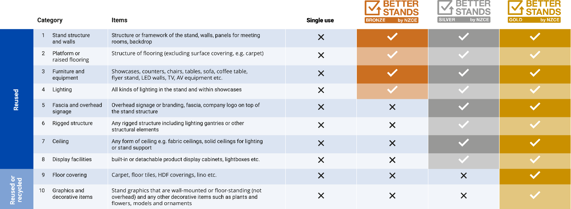
The Better Stands assessment works by assessing 10 elements of a stand build. A stand must meet all the criteria for one level to gain that rating, before being eligible to get the next level.

[N.B. Update this dependant on the way results will be shared: We’ve attached a report with more information that covers all 10 elements. In this report, the elements that were assessed to be reusable are marked as “Y”.]

Thank you for joining us on this programme which we hope will make a meaningful difference to our industry. We really appreciate all your support and want to emphasise what a big step achieving Bronze is.

We look forward to continuing to work with you.

Better Stands Onsite Reporting Team

………………………………………………
[insert name]
Better Stands by NZCE

