
POST-EVENT SERVICE PROVIDER EMAIL TEMPLATE: SINGLE USE

TEMPLATE A: REVIEW STAGE RESULTS
Subject line Option A: Your provisional Better Stands results at [Event Name]
Dear [Service Provider Name],
Thank you for your partnership in building stands at [Event Name].
We’re writing to you as your contact details have been submitted as part of the ‘Stand design submission’ form completed pre-event, but if you’re not the right contact please do pass this onto the relevant person.
We have now completed the onsite assessment at [Event Name] and have a draft Better Stands rating for the stand that you built at [Event Name and year].
Provisional result: Single Use
This provisional rating is based on our team's on-site observations during the event, against the Better Stands framework (see below).
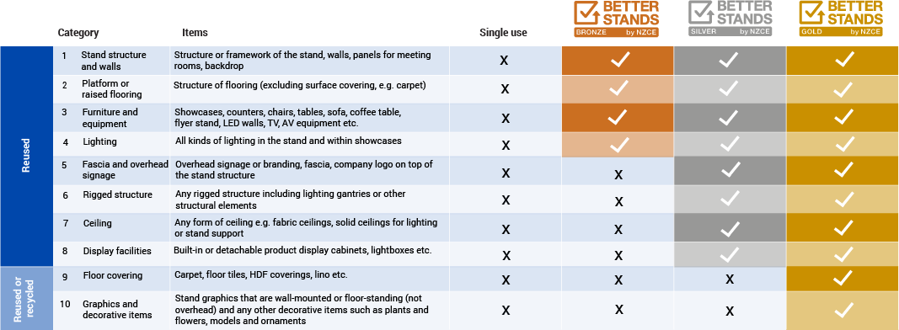
Your detailed report and opportunity to review
For full transparency, the detailed technical report is available for your review below.
- [LINK: Download the Stand Report]
If you have any questions or believe there is incorrect or missing information in the report, you have until [Date 2 weeks from this email being sent] to submit your feedback via our review form [LINK].
After this date, the review window will close, and we will send the final, confirmed rating to you and the exhibitor.
We value your expertise and thank you for your commitment to this important programme.
Best,
The [Event Name] Team / [Third Party Verifier] Team
www.betterstands.org

TEMPLATE B: POST-REVIEW (FINAL) RESULTS
Subject line Option A: Your final Better Stands result at [Event Name]
Dear [Service Provider Name],
Following the 2-week review window, we have now finalised the Better Stands assessment for [Exhibitor Name] at [Event Name].
Final result: Single Use
This means that at least one of the following stand elements were not reused after the event:
- Stand structure and walls
- Platform or raised flooring
- Furniture and equipment
- Lighting
This final rating has now been shared with the exhibitor.
We encourage you to use the insights from the technical report to guide your conversations with exhibitors for future events. We know that achieving a certified stand is a key goal for a rapidly growing number of exhibitors, and early collaboration between the event team, service providers, and exhibitors is the most effective way to achieve this.
We look forward to partnering with you to help our mutual clients achieve a certificate at our next event.
Best,
The [Event Name] Team
www.betterstands.org

