
POST-EVENT SERVICE PROVIDER EMAIL TEMPLATE: SILVER

TEMPLATE A: REVIEW STAGE RESULTS
Subject line Option A: Your provisional Better Stands results at [Event Name]
Dear [Service Provider Name],
Thank you for your partnership at [Event Name].
We’re writing to you as your contact details have been submitted as part of the ‘Stand design submission’ form completed pre-event, but if you’re not the right contact please do pass this onto the relevant person.
We have now completed the onsite assessment at [Event Name] and have a draft Better Stands rating for the stand that you built at [Event Name and year].
Provisional result: Silver
A Silver rating reflects a significant commitment to quality and best practice in stand design, and we thank you for your work in achieving this.
This provisional rating is based on our team's on-site observations during the event, against the Better Stands framework (see below).
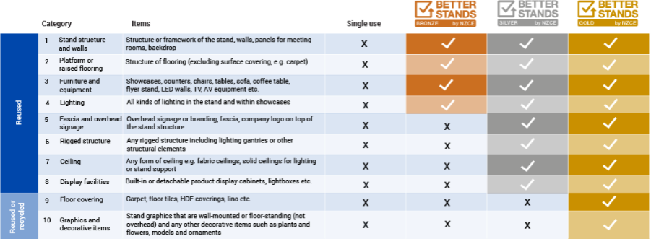

Your detailed report and opportunity to review
For full transparency, the detailed technical report is available for your review. It contains all the on-site observations and explains how the provisional rating was determined.
- [LINK: Download the Stand Report]
If you have any questions or believe there is incorrect information in the report, you have until [Date 2 weeks from this email being sent] to submit your feedback via our review form [LINK].
After this date, the review window will close, and we will send the final, confirmed rating to you and the exhibitor.
We thank you in advance for helping to make a meaningful difference to our industry.
Best,
The [Event Name] Team / [Third Party Verifier] Team
www.betterstands.org

TEMPLATE B: POST-REVIEW (FINAL) RESULTS
Subject line Option A: Congratulations! Your final Better Stands result at [Event Name]
Dear [Service Provider Name],
Following the 2-week review window, we have now finalised the Better Stands assessment for [Exhibitor Name].
Final result: Silver
Congratulations on this fantastic achievement. A Silver-certified stand demonstrates a high level of quality and a commitment to best practice. We have now shared this positive result with the exhibitor.
Showcase your expertise: Tips to spread the word
Achieving a Silver certificate is a valuable credential for your business, proving your ability to deliver high-quality, reusable stands. With a rapidly growing number of exhibitors opting for Better Stands, we are seeing many service providers use this success in their own marketing to attract future clients. We encourage you to consider doing the same - here are a few ideas:
- Update your portfolio: Add photos of this certified stand to your website and sales materials, explicitly labelling it as "Better Stands - Silver Certified."
- Share a case study on social media: Post about the successful project, highlighting how you partnered with your client to meet the Silver standard. Use hashtags #BetterStands, #SilverCertified, #[EventNameYear] and #BetterStandsServiceProvider
- Enhance your sales proposals: Mention your experience in delivering Better Stands certified builds in your proposals to give you a competitive edge.
- Tag us in your posts ([@YourEventSocialHandle]) so we can amplify your success to our wider audience.
Thank you again for your partnership in making [Event Name] a safer and more responsible event.
We look forward to working with you again.
Best,
The [Event Name] Team
www.betterstands.org

