Sustainability
Sustainability is increasingly important to event attendees. Exhibiting at {EVENT} gives you the opportunity to highlight your company’s sustainability credentials and align with an event that champions sustainability.

To ensure that your company and exhibiting stand are aligned with [organisations] sustainability goals:
- View the Exhibitor Sustainability Guidance [input if you offer this as an organiser] and consider the steps as you plan your event
- Consider moving towards a Bronze level stand if not already (find out more below)
Better Stands
Did you know that exhibitors that choose to build reusable stands cut the waste from their stand by up to 80%. Reusable stands are also often safer, easier, cleaner and more reliable to build.

Better Stands is a global programme aiming to ensure that all core elements of exhibitor stands are reusable. Help us to reduce the environmental impact of {EVENT} by committing to the Better Stands programme framework and show that your company values being part of sustainable and socially responsible events.

What’s in it for me?
- A better quality, more attractive & sustainable stand
- Opportunity to promote the sustainable credentials of your brand
- Smoother, more efficient build up and breakdown periods
- Lower work hours and reduced construction costs
- Reduce or eradicate your waste bill
What do I need to do?
To make your commitment to Better Stands and contribute to a more sustainable event:
- Familiarise yourself with the Better Stands framework found below (or click here)
- Share these guidelines with your service provider before they begin designing your stand
- Work toward reaching at least a bronze level, meaning the stand structure and walls, platform or raised flooring, furniture, equipment and lighting are all reused [adjust depending on level chosen]
- Ensure that the submitted stand design clearly communicates how you will meet the Better Stands guidelines

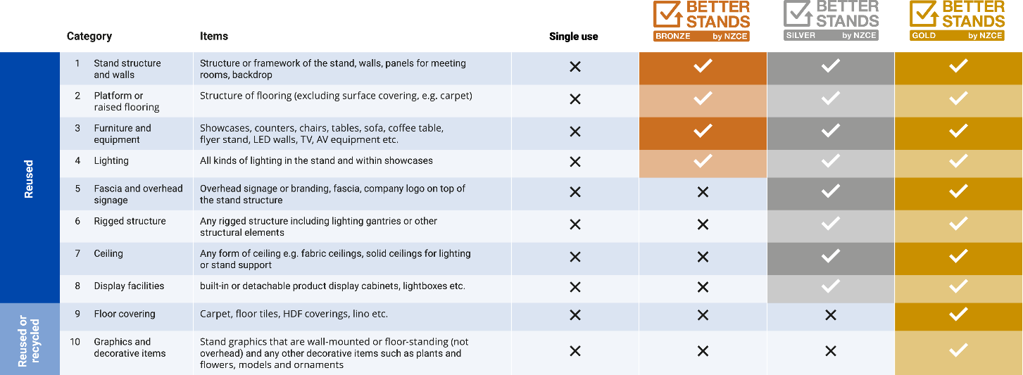

How will we help?
To ensure that all exhibitors can meet the Better Stands guidelines we will:
- Provide a procurement guide supporting you to find contractors that can build reusable stands
- Review your stand designs prior to the permission stage and make you aware of any breaches / Once you have submitted your framework, our stand plan approver will send back information on what you can do reach the Bronze, Silver or Gold Better Stands rating.
- Offer help and advice to find sustainable solutions that suit your needs
- Provide a list of preferred partners with experience producing sustainable stands
- If you tell us all elements of your stand are completely reusable, congratulations! You have already reached the Better Stands Gold standard. Our Better Stands representatives will be onsite during build up and breakdown to check this.
- You will receive an email post show with a report and your Better Stands rating.
If you require any further information or guidance on the Better Stands program, please contact our customer service / sustainability department – xxxx

Breaches of the guidelines will result in a formal written notification, together with continual improvement actions. If any exhibitors continually build unsustainable stands, they will face financial penalties. – N.B. Please note this paragraph should be customised to suit individual Brands implementation plans – will you reward compliance or penalise non-compliance or both?

………………………………………………
[insert name]
Better Stands by NZCE

