Dear [name]

Better Stands
[organisation] is working multiple other event organisers, service providers, venues and associations to deliver a programme called Better Stands. Better Stands celebrates those exhibitors and service providers who choose to build reusable stands instead of single use disposable booths.

Our collective experience suggests that many of these reusable systems are faster, safer, often higher quality and infinitely flexible options that also significantly reduce the waste coming from exhibition booths, sometimes by more than 80% compared to single use wooden booths.

There are many alternative systems to the older style single use disposable booths and we hope that we can all play our part in moving to reusable structures.

Those exhibitor/service providers teams that seek to deliver better stands are awarded bronze, silver or gold ratings based on the results of assessments conducted against a 10 point Better Stands checklist (see below).
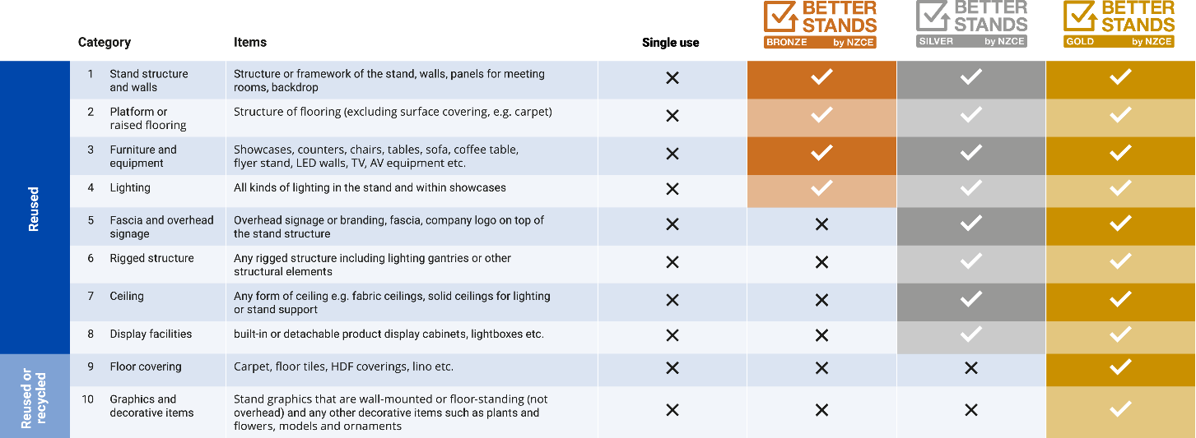

To be awarded at least bronze, the exhibitor and service provider will have chosen a system that ensures the first 4 elements of stand construction are reusable. A silver rating is for those teams who specify the first 8 stand components as reusable. Gold is truly exceptional, and all 10 areas are either reusable or at least recycled in the case of the last 2 elements on the list.

Any exhibitor and service provider scoring at least bronze is doing a great job and should be proud of that.

Rolling out Better Stands

[Change to suit your approach, example given below]
At our event, we choose to conduct a 3-stage assessment:
- We request pre-show information from the service provider to ask their honest assessment of whether they will be reusing each of the 10 components listed in the Better Stands framework
- Onsite assessments are conducted by an experienced assessor/third-party. They will seek to visit every space only booth during build and breakdown but may target their work on specific areas based on the pre-show assessment. They keep records and photos of their work to help with everyone's learning and later discussions.
- These assessment results are then shared with the service providers around a month after the event and before notification is given to the exhibitors. This gives the service providers a short period of time to respond to the assessment if they feel that the rating they were given was inaccurate. If successful, adjustments are made.

Following that, the exhibitors who've chosen at least a bronze stand are written to acknowledge their commitment to better stands, and those who didn't quite make it to bronze are given ideas and suggestions on how and why they might want to choose reusable in future.

Other events implementing Better Stands may be choosing a slightly different approach, but we are coordinating across all of the participating events, along with associations and a service provider working group, to ensure consistent and fair participation that celebrates those service providers and exhibitors who're choosing a more sustainable option.

………………………………………………
[insert name]
Better Stands by NZCE

