Better Stands Programme – Exhibitor Invitation and Information Sharing

Dear [name]

Our events wouldn’t be successful without 1000s of exhibitors partnering with us to showcase the latest [innovations / products / tech] in their respective markets.

We all know that a great show really comes from successful partnerships, but even better long-term success comes from having one eye to the future. Over the last decade, we’ve seen attendees and participants become more interested in, and have higher expectations, of our events. This ranges from the quality of the content, the safety of people, the diversity of attendees and the sustainability of our builds.

With that in mind, we are part of the global Better Stands programme. The goal of this is to celebrate those exhibitors and their service providers who choose to use reusable [booths/stands] as we believe they provide a better experience for everyone.

We are writing to you to explain more, and hope that you’ll join us on this programme. [In (insert year) we introduced/next edition we plan to introduce], where we will be encouraging exhibitors to choose reusable stands. By moving towards reusable [booths/stands], we believe that we will improve the exhibitor experience as well as meet growing stakeholder demands for a more sustainable event.

We have had feedback from many exhibitors, who see a number of benefits from using reusable [booths/stands]:
- A smoother, more predictable and stress-fee build and dismantle experience for all parties
- Reduced waste bills and less likelihood of other unpredicted costs
- Reusable [booths/stands] reduce the likelihood of accidents and incidents occurring during the build and dismantle of your stand
- Reflect your brand’s commitment to sustainability – as you’re reducing waste and emissions by choosing a reusable stand
- Reusable [booths/stands] also reduce the likelihood of requiring early access or late working with subsequent additional costs
There are now hundreds of events around the world participating in the Better Stands programme, with a fast-growing list of organisers, venues, service providers, associations and assessor companies implementing the Better Stands framework and working with their clients to move to reusable stands. To find out more please visit www.betterstands.org/. [Include as necessary: As part of this programme, this means there are key changes to our stand construction guidelines to move towards this goal.]

We really value your support in helping ensure our events are safer and less wasteful. We will be starting to implement the Better Stands programme at the next edition in 202X.

For the upcoming event:
- Read the Better Stands framework below
- Read the Better Stands procurement guide
- Work with us to ensure the stand you are building reaches your preferred level, meaning the stand structure and walls, platform, furniture, equipment, and lighting are all reused, by our event in 202X. By reuse we mean that the component of the stand is used at more than one event. Recycling or repurposing the component outside of an exhibition stand does not count.
- [REMOVE IF NOT IMPLEMENTING THIS: Work with your service providers to complete the pre-event stand assessment on the Better Stands platform. For this read the procurement guide.]

We will be offering both options, pre-event assessments and onsite assessments, to check how each stand compares against the framework above and will use information submitted by you and your service provider in advance to help with that, if we can. Service providers will have the ability to review this rating before it is sent to you.

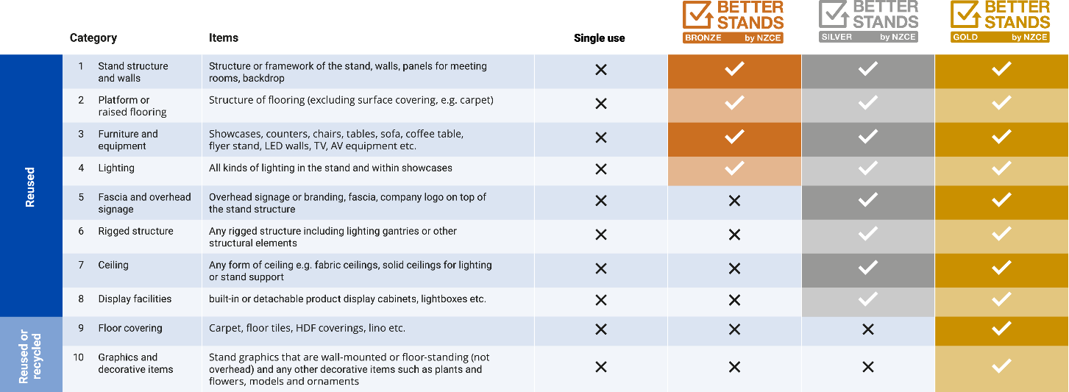

Better Stands Onsite Reporting Team

………………………………………………
[insert name]
Better Stands by NZCE

