Sustainability
Sustainability is increasingly important to event attendees. Exhibiting at {EVENT} gives you the opportunity to highlight your company’s sustainability credentials and align with an event that champions sustainability.

To ensure that your company and exhibiting stand are aligned with [organisations] sustainability goals:
- View the Exhibitor Sustainability Guidance [input if you offer this as an organiser] and consider the steps as you plan your event
- Consider moving towards a Bronze level stand if not already (find out more below)

Better Stands

At [Event Name], we believe the most impactful stands are those built with a vision for the future. That’s why we’re inviting you to participate in our voluntary Better Stands pre-event assessment—a journey toward a smarter, safer, and more sustainable exhibition.

Better Stands is uniting the events and exhibitions industry to adopt reusable stands, ensuring smarter, safer and more sustainable solutions globally.

Using a simple 10-point framework, organisers, venues, exhibitors, service providers, assessors and associations celebrate the use of reusable stands, inspiring change through awareness and engagement.
Help us to reduce the environmental impact of {EVENT} by committing to the Better Stands programme framework and show that your company values being part of sustainable and socially responsible events.

What’s in it for me?

A better quality, more attractive & sustainable stand
- Opportunity to promote the sustainable credentials of your brand
- Smoother, more efficient build up and breakdown periods
- Lower work hours and reduced construction costs
- Reduce your waste bill

To make this process effortless for your team, we highly recommend partnering with a Better Stands Registered Service Provider.

Partnering with a registered service provider isn't just a sustainable choice—it’s a smart business decision that ensures your presence at [Event Name] is both memorable and responsible.

Ready to find your partner? Visit List of Members - Better Stands to start your journey today.
How does it work?

{EVENT} is offering exhibitors the opportunity to participate in the Better Stands initiative before the event takes place.

The pre-event assessment allows exhibitors and their appointed stand builders or service providers to submit detailed information about their stand design and construction methods in advance. This includes key aspects such as the materials used, structural elements, and overall build approach.
By submitting your stand plans early, you will receive an assessment prior to the event. This gives you the opportunity to review your planned build, make improvements where necessary, and enhance your Better Stands rating before arriving on site.

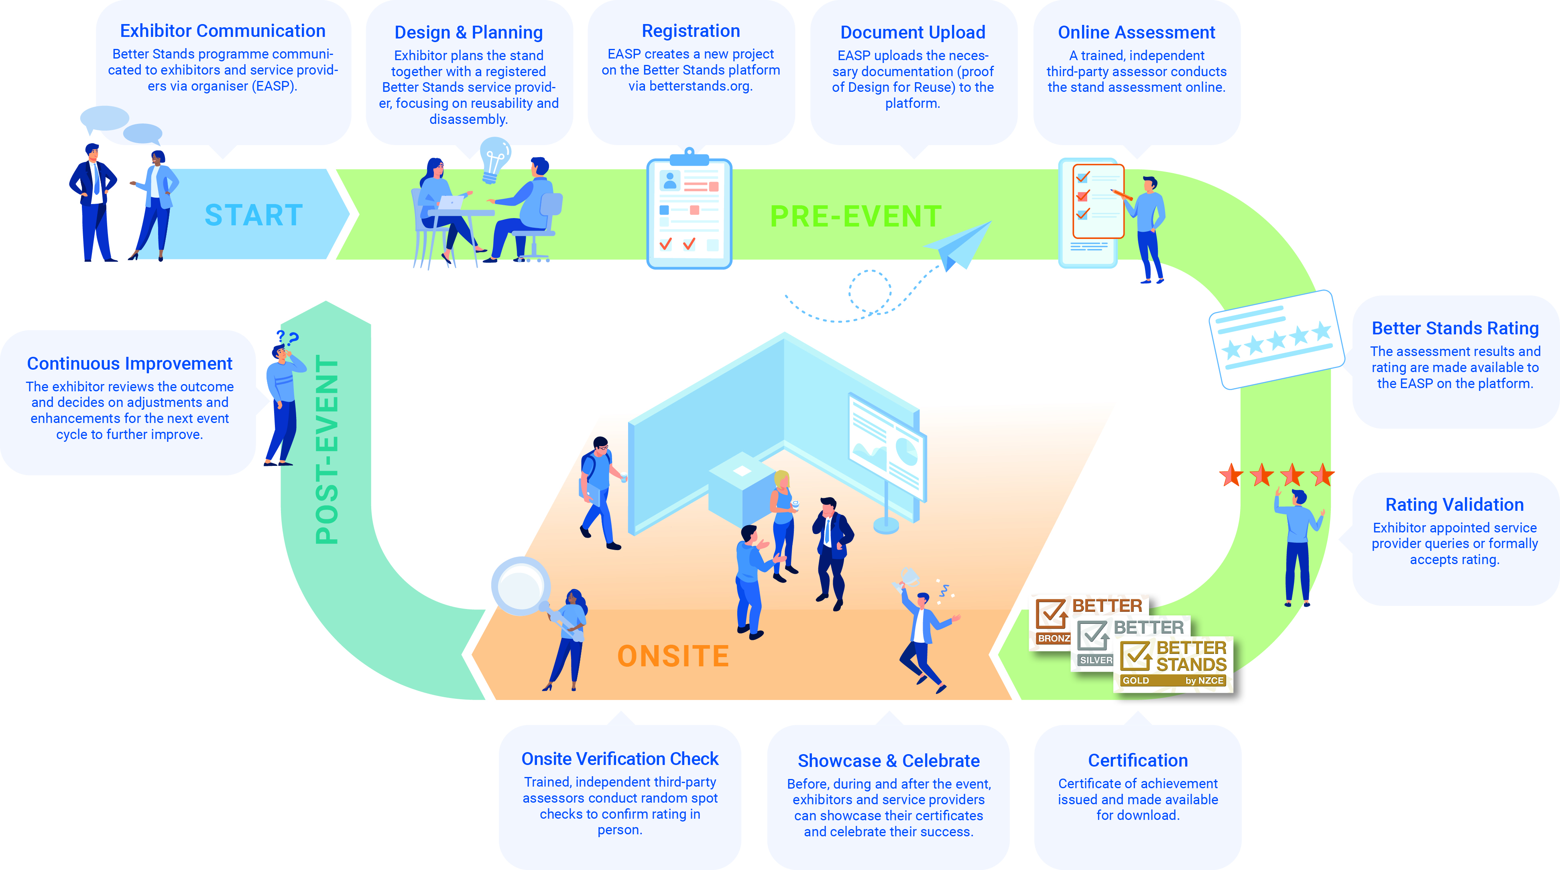

What do I need to do?
To make your commitment to Better Stands and contribute to a more sustainable event:

- Familiarise yourself with the Better Stands framework found below:
Review the Better Stands framework. This will help you understand the different classification levels (Bronze, Silver, Gold) and the requirements for each.

- Ensure your stand builder is a Better Stands member:
For the pre-event assessment, your appointed stand builder or service provider must be a registered Better Stands member.
Please check the official Better Stands members list to confirm that your chosen service provider is registered or choose a registered service provider from the list of members.
Click here: List of Members - Better Stands
Or go directly to: www.betterstands.org

- If your stand builder is not yet a member:
If your preferred and appointed stand builder or service provider is not currently a Better Stands member:
- Share the Better Stands information with them which can be found on the Better Stands website: For Service Providers - Better Stands
- Encourage them to register as a Better Stands member
- For any questions about the membership, they can contact: info@betterstands.org
- Once your preferred service provider is registered, they will receive full guidance by the Better Stands secretariat on how to meet the requirements and complete the stand assessment process.

- Work towards your target level:
Plan your stand with the aim of reaching a minimum of Bronze (or the level selected by the event), meaning at least the stand structure and walls, platform or raised flooring, furniture, equipment and lighting are all reused.

- Stand submission on the Better Stands platform (this is your service providers’ task):
Your appointed service provider will:
- Create a project for your stand on the Better Stands platform
- Upload all required documentation and evidence demonstrating the reusability of your stand
Registered Better Stands members are familiar with this process and will know exactly what documentation is required.
- Certification and Celebration
Once your stand assessment has been reviewed and approved, and your Better Stands level (Bronze, Silver, or Gold) has been confirmed, you will receive an official certificate for your stand.
You can then proudly communicate and celebrate your achievement and your commitment to more sustainable exhibiting — before, during, and after the event.

If you require any further information or guidance on the Better Stands program, please contact our customer service / sustainability department – xxxx

………………………………………………
[insert name]
Better Stands by NZCE

