Better Stands Programme – Service Provider Pre Event Information

Dear [name]

Our events wouldn’t be successful without 1000s of service providers around the world doing a fantastic job in helping exhibitors, as our mutual customers, have a successful show.

We all know that a great show really comes from successful partnerships, but even better long-term success comes from having one eye to the future. Over the last decade, we’ve seen attendees and participants become more interested in, and have higher expectations, of our events. This ranges from the quality of the content, the safety of people, the diversity of attendees and the sustainability of our builds.

With that in mind, we are part of the global Better Stands programme. The goal of this is to celebrate those exhibitors and their service providers who choose to use reusable [booths/stands] as we believe they provide a better experience for everyone. To support this mission, we’ve introduced the Better Stands pre-event assessment.

We are writing to you to explain more, and hope that you’ll join us on this programme. [In (insert year) we introduced/next edition we plan to introduce], where we will be encouraging exhibitors to use reusable [booths/stands]. By moving towards reusable [booths/stands], we believe that we will improve the exhibitor experience as well as meet growing stakeholder demands for a more sustainable event.
By joining Better Stands, you aren't just meeting a requirement—you’re positioning your team as a preferred, forward-thinking provider. It’s a simple way to:

- Increase visibility: Be seen by exhibitors specifically seeking new partners, who align with their values.
- Empower your clients: Provide exhibitors with their official certification before the doors of the event even open.
- Lead the industry: Showcase your commitment to sustainable innovation.

We would love to have you on board as we build a more sustainable industry together!

You can find more details below and on www.betterstands.org and For Service Providers - Better Stands

Better Stands

Better Stands is uniting the events and exhibitions industry to adopt reusable stands, ensuring smarter, safer and more sustainable solutions globally.
Using a simple 10-point framework, organisers, venues, exhibitors, service providers, assessors and associations celebrate the use of reusable stands, inspiring change through awareness and engagement.
There are many alternatives to the older style single use disposable booths, and we hope that we can all play our part to move to these alternatives.

Those exhibitor/service provider teams that seek to deliver better stands are awarded bronze, silver or gold ratings based on the results of assessments conducted against a 10 point Better Stands checklist (see below).

You can find out more on the on the Better Stands website.

Our plans for [INSERT EVENT NAME AND YEAR]:

Pre- Event Assessment:

{EVENT} is offering exhibitors the opportunity to participate in the Better Stands initiative before the event takes place.
The pre-event assessment allows exhibitors and their appointed stand builders or service providers to submit detailed information about their stand design and construction methods in advance. This includes key aspects such as the materials used, structural elements, and overall build approach.
By submitting your stand plans early, you will receive an assessment prior to the event. This gives you the opportunity to review your planned build, make improvements where necessary, and enhance your Better Stands rating before arriving on site.

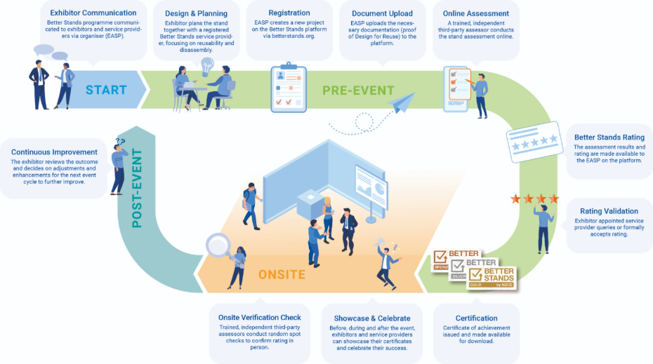

What do I need to do?

To make your commitment to Better Stands and contribute to a more sustainable event:

- Familiarise yourself with the Better Stands framework found above:
Review the Better Stands framework. This will help you understand the different classification levels (Bronze, Silver, Gold) and the requirements for each.

- If your company is not yet a Better Stands member:
For the Better Stands pre-event assessments your company must be a Better Stands member.
- All information about the membership and the benefits can found on the website: For Service Providers - Better Stands
- Once you are ready, register on the website to become a member.
- For any questions about the membership, contact: info@betterstands.org

- Your company is already a Better Stands Member:
The assessor (appointed by the event organiser) is setting up the event on the platform.
Now it is your turn:
1.Log In to your account on the Better Stands platform: Login - Better Stands
2.Click the "New Project" button.
3.Navigate to "Events"-dropdown and select your specific exhibition event from the list.
4. Confirm & Start: Your project is now linked, and you can begin submitting your stand details for certification.
5. Assessment: After you have completed your full submission, the assessor will review your documents and provide feedback on your achieved Better Stands rating. You will still have the opportunity to improve your stand and upload additional evidence.
6. Better Stands Certificate: Once you have received your final Better Stands rating for your exhibition stand, you can download your certificate and use it for promotional purposes. You may also share it with your customer, the exhibiting company, so it can be displayed on the stand during the event.

Please let us know if you have any questions: info@betterstands.org

Better Stands Onsite Reporting Team

………………………………………………
[insert name]
Better Stands by NZCE

