Better Stands Programme – Service Provider and Exhibitor Appointed Contractor Invitation and Information Sharing

Dear [name]

Our events wouldn’t be successful without 1000s of service providers around the world doing a fantastic job in helping exhibitors, as our mutual customers, have a successful show.

We all know that a great show really comes from successful partnerships, but even better long-term success comes from having one eye to the future. Over the last decade, we’ve seen attendees and participants become more interested in, and have higher expectations, of our events. This ranges from the quality of the content, the safety of people, the diversity of attendees and the sustainability of our builds.

With that in mind, we are part of the global Better Stands programme. The goal of this is to celebrate those exhibitors and their service providers who choose to use reusable [booths/stands] as we believe they provide a better experience for everyone.

Better Stands is uniting the events and exhibitions industry to adopt reusable stands, ensuring smarter, safer and more sustainable solutions globally.
Using a simple 10-point framework, organisers, venues, exhibitors, service providers, assessors and associations celebrate the use of reusable stands, inspiring change through awareness and engagement.
There are many alternatives to the older style single use disposable booths, and we hope that we can all play our part to move to these alternatives.

Those exhibitor/service provider teams that seek to deliver better stands are awarded bronze, silver or gold ratings based on the results of assessments conducted against a 10 point Better Stands checklist (see below).

We are writing to you to explain more, and hope that you’ll join us on this programme. [In (insert year) we introduced/next edition we plan to introduce], where we will be encouraging exhibitors to use reusable [booths/stands]. By moving towards reusable [booths/stands], we believe that we will improve the exhibitor experience as well as meet growing stakeholder demands for a more sustainable event.

We have had feedback from many service providers who already supply reusable [booths/stands] that they can provide a number of benefits:
- A smoother, more predictable and stress-fee build and dismantle experience for all parties
- Reusable [booths/stands] reduce the likelihood of requiring early access or late working with subsequent additional costs
- Increased client retention rates as exhibitors are more likely to reuse you as their service provider if you meet the desired standard
- More frequent success in tenders due to the boost from sustainability credentials
- Reduced waste bills and less likelihood of other unpredicted costs
- Easier process of monitoring and improving safety – Reusable [booths/stands] reduce the likelihood of accidents and incidents occurring during the build and dismantle of your [booth/stand]
- Reduced challenges with labour shortages
- Cleaner build for you and for your neighbours

There are now hundreds of events around the world participating in the Better Stands programme, with a fast-growing list of service providers, organisers, venues associations and assessor companies implementing the Better Stands framework and working with their clients to move to reusable stands. To find out more please visit www.betterstands.org/. [Include as necessary: As part of this programme, this means there are key changes to our stand construction guidelines to move towards this goal.]
We really value your support in helping ensure our events are safer and more sustainable. We will be starting to implement the Better Stands programme at the next edition in 202X.

To support this mission, we’ve also introduced the Better Stands pre-event assessment alongside the onsite assessment.

We know that achieving this depends entirely on the expertise of partners like you. To help our exhibitors connect with the right experts, we are highlighting Better Stands registered service providers—and we’d love to see your organisation on that list!

By joining Better Stands, you aren't just meeting a requirement—you’re positioning your team as a preferred, forward-thinking provider. It’s a simple way to:

- Increase visibility: Be seen by exhibitors specifically seeking new partners, who align with their values.
- Empower your clients: Provide exhibitors with their official certification before the doors of the event even open.
- Lead the industry: Showcase your commitment to sustainable innovation.

We would love to have you on board as we build a more sustainable industry together!

You can find more details below and on www.betterstands.org and For Service Providers - Better Stands

Our plans for [INSERT EVENT NAME AND YEAR]:
We will be offering both options, pre-event assessments and onsite assessments, to check how each stand compares against the Better Stands framework.

Pre-Event Assessment:
The pre-event assessment enables exhibitors, along with their appointed stand builders or service providers, to submit detailed information about their stand design and construction methods in advance through the Better Stands platform. This process is complemented by on-site spot checks to ensure consistency and compliance. Key aspects covered include the materials used, structural components, and the overall construction approach.
By submitting your stand plans early, you will receive an assessment prior to the event conducted by trained and independent assessors. This gives you the opportunity to review your planned build, make improvements where necessary, and enhance your Better Stands level as well as communicating and celebrating it before, during and after the event.

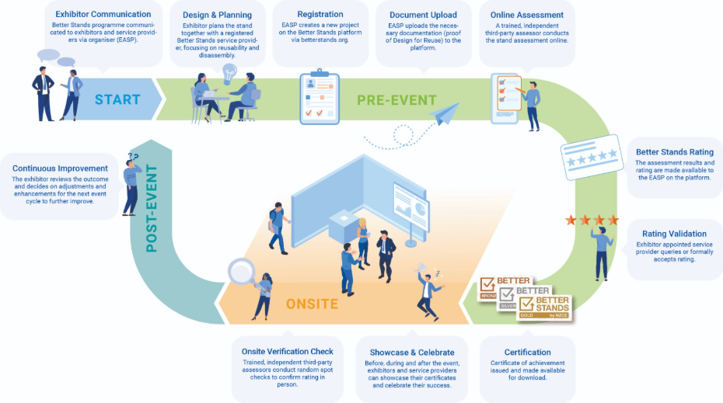

What do I need to do for a pre-event assessment?

To make your commitment to Better Stands and contribute to a more sustainable event:
- Familiarise yourself with the Better Stands framework found below (or click here):
Review the Better Stands framework. This will help you understand the different classification levels (Bronze, Silver, Gold) and the requirements for each.

- If your company is not yet a Better Stands member:
For the Better Stands pre-event assessments your company must be a Better Stands member.
- All information about the membership and the benefits can found on the website: For Service Providers - Better Stands
- Once you are ready, register on the website to become a member.
- For any questions about the membership, contact: info@betterstands.org

- Your company is already a Better Stands member:
The assessor (appointed by the event organiser) is setting up the event on the platform.
Now it is your turn:
1.Log In to your account on the Better Stands platform: Login - Better Stands
2.Click the "New Project" button.
3.Navigate to "Events"-dropdown and select your specific exhibition event from the list.
4. Confirm & Start: Your project is now linked, and you can begin submitting your stand details for certification.
5. Assessment: After you have completed your full submission, the assessor will review your documents and provide feedback on your achieved Better Stands rating. You will still have the opportunity to improve your stand and upload additional evidence.
6. Better Stands Certificate: Once you have received your final Better Stands rating for your exhibition stand, you can download your certificate and use it for promotional purposes. You may also share it with your customer, the exhibiting company, so it can be displayed on the stand during the event.

Onsite Assessment:

During the build-up and dismantling phases, exhibitors’ stands are assessed on site against the Better Stands framework by trained, independent assessors. The evaluation includes observation of the construction and deconstruction process, as well as discussions with appointed service providers to verify compliance and determine the final level. This enables you to communicate and celebrate your achieved Better Stands level after the event.

What do I need to do for an onsite assessment?

- Read the Better Stands framework below – you can find more information on: www.betterstands.org
- Work with us to ensure the stand you are building reaches at least a Bronze level, meaning the stand structure and walls, platform, furniture, equipment, and lighting are all reused, by our event in 202X. By reuse we mean that the component of the stand is used at more than one event. Recycling or repurposing the component outside of an exhibition stand does not count.
- [REMOVE IF NOT USING: Complete the pre-event stand design submission questions in the exhibitor portal stating which categories of the components of the stand you plan to reuse]

Please let us know if you have any questions: info@betterstands.org

Better Stands Onsite Reporting Team

………………………………………………
[insert name]
Better Stands by NZCE

